The 47th annual Melissa’s Road Race will take place on Saturday, September 26th, 2026. The runners are excited to participate including many locals from right here in the Bow Valley. The Official Charity is the Daycare Society of Banff, and the event will also make contributions to many other local groups.

The running route and timing is the same as in 2025 with traffic impacts occurring between 10:30am and 2:00pm (listed below). The course will be managed by professional traffic controllers and has been designed to limit impacts on traffic in and around Banff. Please take note of the Banff Ave Bridge closure and delays to the Golf Course. Use alternative routes as signed or allow time for delays during these periods. Your understanding and cooperation is greatly appreciated.

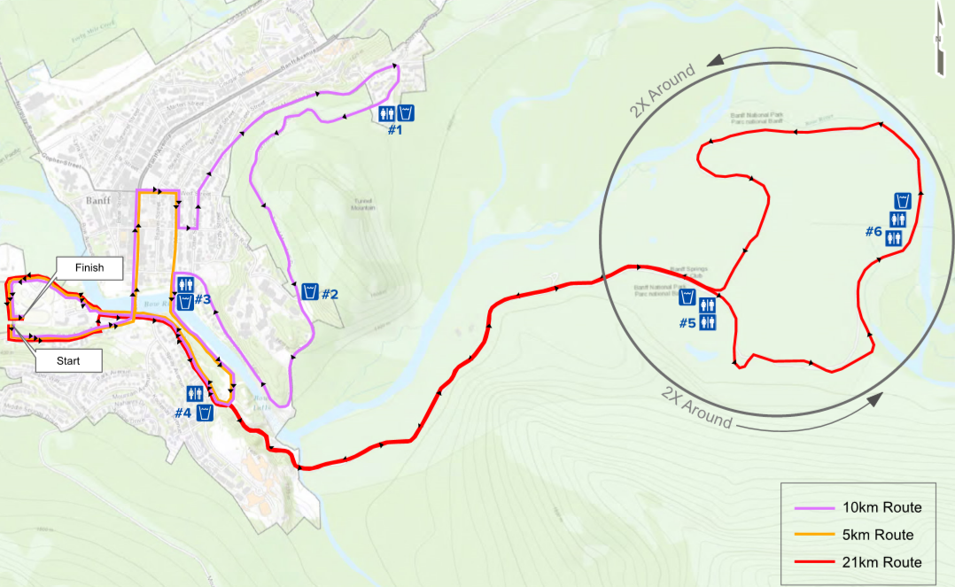

Melissa’s Road Race - Traffic interruptions during the event:
Saturday, September 26th, 2026 - 10:30am to 2:00pm

Roads Affected:

Cave Ave:
Full closure from 10:30am - 10:55am
Sundance Rd:
Full closure 7:30am - 3:30pm
Banff Ave (including vehicle bridge) from Cave Ave to Wolf St:
Bridge fully closed and Banff Avenue northbound lanes closed 10:35am – 11:00am. Rolling reopening
Wolf St, from Banff Ave to Muskrat St:
Single lane closure 10:35am - 11:00am. Rolling reopening

Muskrat St, from Wolf St to Buffalo St:
Single lane closure 10:35am - 11:00am. Rolling reopening

Caribou St from Muskrat St to Otter St:
Single lane closure 10:35am - 11:05am. Rolling reopening
Otter St. / Tunnel Mtn Rd, from Caribou St to Tunnel Mountain Drive (at Buffalo Mountain Lodge)
Single lane closure 10:35am – 11:35am. Single lane access to main entrance of Buffalo Mountain Lodge
Tunnel Mountain Drive from Buffalo Mountain Lodge main entrance to south Parks Gate on Tunnel Mountain Drive (at St. Julien Way – entrance to Banff Centre):
Full closure 7am – 12 noon. Tunnel Mountain Drive gates will open to the public at 12 noon
Park gates will remained locked from 9pm night before (Friday)
Tunnel Mountain Drive / Buffalo Street from St. Julien Way to Muskrat St:
Single lane closure 9am – 12 noon. Southbound traffic only in right lane, descending). Vehicles can exit Banff Centre (right turn only). Ascending traffic lane on Tunnel Mountain Drive is closed until the last runner enters the trail system at Muskrat Street. Access to The Banff Centre is via St. Julien Rd (follow detour).
Eastern Pedestrian Bridge:
Dedicated lane to runners until 12:30pm
Birch Ave and Birch Drive:
Full closure from 10:25am - 11:00am
Single lane access from 11:00am – 2:00pm to the Luxton Museum, Trading Post and residences via Cave Ave/Birch Drive only
Glen Ave:
Full closure at 10:30am - 10:50am
Single lane closure (westbound): 10:50am – 2:00pm
Single lane traffic access eastbound – Local Traffic Only: 10:50am – 12:30pm (access via Trading Post)
Single lane traffic access eastbound – All Traffic: 12:30pm – 2:00pm
Bow Falls Ave:
Full closure 10:30am – 10:50am. After last runner passes by Bow Falls parking lot, two-way traffic allowed until runners return, then single lane alternating traffic (radio controlled) until approximately 1:45pm
Golf Course Rd:
Single lane access via pilot vehicle 10:30am - 1:30pm. Please stage in the designated parking area to await the pilot vehicle. Departures are approximately every 20 minutes. Golf Course Rd loop – closed from 9:00am – 1:45pm

*Please note that these interruptions could be extended 90 minutes in the case of a delay for wildlife

